Homeowner Handbook

What is the Homeowner Handbook?

The Homeowner Handbook is a tool. It is meant to provide new homeowners with resources to answer questions, perform necessary repairs and maintenance, and to know when it’s appropriate and who to contact about warranty work or repairs that require a professional.

How to Use this Handbook

The Homeowner Handbook is set up alphabetically by categories that relate to the areas of your house.

This handbook is updated periodically to reflect the most up-to-date information on home maintenance and construction practices that were used to build your home. The most recent version can always be found at our website: http://www.habitatbuffalo.org or by requesting a paper copy from the family services manager at our office

While most of the maintenance and repair information will not change, we still urge you to update which version you have at least every other year.

Caring For Your New Home

Your home has been constructed with quality materials and the labor of experienced professionals and volunteers with care. Prior to our using any material or supply, it must meet our specifications for quality and durability. All work is performed under the supervision of qualified Habitat Buffalo staff to meet all applicable building code requirements and quality guidelines set forth in our construction program.

Although quality materials and workmanship have been used in your home, this does not mean that it will be free from care and maintenance. A home – whether it’s newly constructed, or rehabbed or remodeled -- requires care and attention from day one. General homeowner maintenance is essential to providing a quality home for a lifetime.

Habitat for Humanity Buffalo is proud of the product we built and our aim is to create lasting value. This cannot be achieved unless you, as the homeowner, properly maintain your home and all of its components. Periodic maintenance is necessary because of normal wear and tear, climatic condition, the inherent characteristics of various materials used in your home and normal service required by the mechanical systems. Natural fluctuations in temperature and humidity also impact your home.

Many times a minor adjustment or repair done immediately by you saves you a more serious, time-consuming, and costly repair later. Note also, that negligence of routine maintenance can void applicable limited warranty coverage on all or part of your home.

We recognize that it is impossible to anticipate and describe every attention that may be needed for good home care; however, we have covered many important details. The subjects covered include major components of our homes, listed in alphabetical order. Each topic includes suggestions for your use and care followed by Habitat warranty standards. Not all components listed are included in every Habitat home.

We make every effort to keep our information current and accurate Activate specific manufacturer warranties by completing and mailing the registration cards included with their materials. In some cases, manufacturer warranties may extend beyond the first year; it is in your best interest to be aware of such coverage.

Limited Warranty

Homeowners will receive and sign a Homeowner’s Limited Warranty at the time of move-in or closing. This warranty describes coverage for issues caused by material defects or workmanship. The Homeowner’s Limited Warranty can be found as an appendix to this handbook.

Reporting Procedures

Habitat for Humanity Buffalo performs warranty walthroughs at 30-day, 4 month, and 11 month intervals after possession. Non-emergency warranty issues will only be addressed at those walkthroughs.
Whenever a potential emergency warranty issue arises – including loss of power, water or heat -- it is the homeowner’s responsibility to report it to Habitat for Humanity Buffalo’s main office by calling 716-204-0740 or emailing info@habitatbuffalo.org.
A Habitat staff member will record your warranty concern and respond in a reasonable amount of time regarding whether the item is covered under warranty, and if necessary, schedule a time to perform work to resolve the issue.

Emergency Service

Emergencies, as defined by Habitat, include the following. If these issues happen within the warranty period, contact Habitat. If it is a holiday or weekend, and immediate service is required, contact professionals per the list below:

- Gas leak. (Leave your house immediately and contact your utility company or 911
- Total loss of heat when the outside temperature is below 45 degrees. Call the heating company that installed the furnace (phone number listed on thermostat and/or furnace) or another heating company.
- Total loss of electricity. This means all power to the entire house. For power failure to one room or outlet, check to see if GFCI’s or breakers are tripped. (Check with your utility company prior to reporting this circumstance to Habitat; Call an electrician).
- Plumbing leak that requires the entire water supply be shut off. Shutoff the water and call a plumber.
- Total loss of water. (Check with your water department to be certain the problem is not a general outage in the area).

Appliances

The manufacturers of kitchen and laundry appliances will work directly with you if any repairs are needed for those products within the warranty period. Be prepared to provide the model and serial number of the item and the closing date on your home. Appliance warranties are generally for one year; refer to the literature provided by the manufacturer for complete information. Extended warranties are not available through Habitat but may be available through the manufacturers.

Use and Care

Read and follow all manufacturer requirements for each appliance in your home. Register appliances for warranties and refer to the appliance manual for warranty information.

Below are the appliances – both standard and optional – provided in Habitat Buffalo homes as of this handbook version:

Range Hood
Whirlpool UXT4230AD (standard) or
Whirlpool WMH31017H (microwave/range hood combo. Optional upgrade)

General Info:
Whenever feasible, the range hood is vented directly to the exterior of your home, helping to exhaust stale, moist air and fumes/gases associated with cooking. However, sometimes the design of the house does not allow this, in which case, the range hood recirculates the air.

The range hood should be operated whenever the stove is in use.

Standard Maintenance:
The mesh filter should be cleaned regularly – look for yellow or brown sticky build up. Simply remove from the unit, wash in warm soapy water, rinse, dry and re-install.

Gas Range (Stove/Oven)
Whirlpool Model WFG320M0B

General Info:
As mentioned above, always use your range hood when cooking on the stovetop.

The gas shutoff for the gas range is located behind the range. Simply slide out to turn off if needed. There is no need to utilize the shutoff for normal operation.

Standard Maintenance:
Keeping the stove and oven clean can improve efficiency and lifetime of the appliance, as well as prevent smoke and reduce potential for fire.

Water Heater (tankless or “on-demand”)
Rinnai RL75iN

General Info:
This appliance heats water as you use it by heating natural gas. 120 degrees is the default setting when you move in your home.
Exhaust gases are directed through a vent to the outside of the house. If this vent becomes damage, covered with snow, or obstructed in any way, gases will potentially flow back into the house, or more likely, the water heater will shut down.

Standard Maintenance:

In order for the water heater to work efficiently and last as long as possible, it needs to be flushed once per year by a plumber or handyman.
Keep the exhaust vent clear of obstructions.
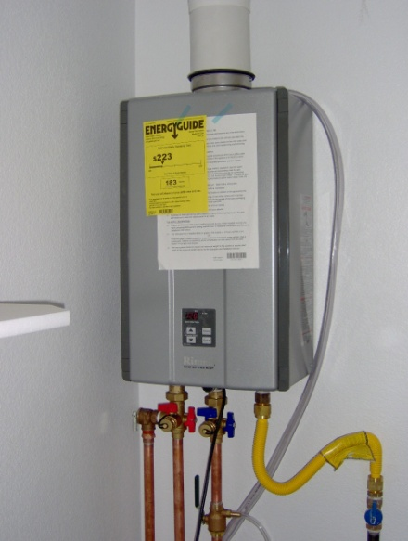

Refrigerator
Whirlpool WRT138FZD

General Info:
Adjustments to the temperature can be made using dials located in the freezer and refrigerator.

Standard Maintenance:
To help maintain efficient operation, vacuum/dust the evaporator coil located behind or underneath the fridge at least once a year.

Washing Machine (optional)
Whirlpool WTW5000DW

General Info:
Your front-loading washing machine requires special detergents. Carefully follow the manufacturer’s directions for using it. Once you close the door and turn the washer on, the door will lock automatically and can’t be opened until the washing cycle is complete. The shut-off valves are located behind the machine.

Standard Maintenance:
To help prevent mold growth in your washing machine’s tub leave the door slightly open between uses to prevent moisture build-up

Clothes Dryer (optional)
Whirlpool WGD5000DW

General Info:
The shutoff for the gas dryer is located behind the appliance. There is no need to utilize the shutoff for normal operation

Standard Maintenance:
Because it uses gas to heat air to operate, a clothes dryer can be a potential fire hazard. To reduce risk, as well as to improve efficiency and lifetime of the appliance, clean the lint trap before each use.
Once a year, clean the entire exhaust pipe as well as the exhaust hood on the outside of the house.

LIMITED WARRANTY

Habitat is not responsible for any warranties on appliances.

All appliance warranties are assigned to you when you take possession of the home. The appliances are warrantied directly to you in accordance with the terms and conditions of the written warranties supplied by the manufacturers.

Mail warranty registration cards directly to the manufacturer. Failure to do this may result in negation of your warranty.

If a problem arises with an appliance, call the customer service number listed in the manufacturer’s warranty. When reporting warranty items to the appliance manufacturer, be prepared to supply the following:

- The date of purchase (closing);
- The serial and model numbers (found on a metal plate on side or bottom of each appliance);
- A description of the problem.
Attic Access

General Info:

Some rehabbed Habitat Buffalo homes have a pulldown attic access or a stairway to the attic. Attics are unfinished and unconditioned spaces and any storage of items in the attic is done at the homeowner’s risk

Brick and Masonry

Use and Care

Some rehabbed Habitat Buffalo homes have masonry (stone, concrete block, or brick) foundation and exterior elements. Over several years, the mortar joints may need to be repointed (additional grout or mortar applied). Other than that, no maintenance is required aside from recommended annual cleaning with soap and water or a light duty pressure wash.

Cabinets

Use and Care

Products such as lemon oil, Liquid Gold, and Old English Furniture Polish and Scratch Cover are suggested for caring for wood finish cabinets. Follow container directions; do not use more than once a month to protect against excessive buildup. Avoid paraffin-based spray or washing cabinets with water, as both will damage the luster of the finish.

If hinges catch, or drawer glides become sluggish, a small amount of lubricant will improve their action. Door height can be adjusted by loosening the screws that attach the hinge to the door, and then tightening the screws once desired position is achieved.

LIMITED WARRANTY

Cabinets should operate properly under normal use. Doors, drawer fronts, and handles should be level and even. There is a one-year warranty for material defects from manufacturer and/or improper installation only.

Warping

Warped doors or drawer fronts will be corrected if warpage is in excess of ¼” within 24” during the one-year warranty period.

Separations

Gaps between cabinets and ceiling, or cabinets and walls will be corrected by caulking or other means if they are in excess of ¼” within the one-year warranty period (locations behind appliances are an exception).

Wood Grain

Readily noticeable variations in wood grain and color are expected. Replacements will not be made due to such variations.

Surface Damage

Chips, scratches, and other surfaces flaws noted at the end of construction will be repaired.

Caulking

Use and Care

Time and weather will shrink caulking and dry it out so that it no longer provides a good seal against moisture and air infiltration. As a matter of routine maintenance, it is wise to check the caulking and make repairs as needed. Caulking compounds and dispenser guns are available at hardware stores. Read the label to make sure the product that you are buying suits the purpose that you intend to use it for.

Silicone Caulk

Caulking that contains silicone will not accept paint but works well where water is present (for example, where the tub meets wall or sink meets countertop).

Latex Caulk

Latex caulking is appropriate for an area that requires painting (along the stair stringer or where trim meets the wall).

Concrete

Use and Care

Foundation

New Builds:
The foundation for every new construction home has been designed and installed in accordance with applicable engineering specifications and building codes. The walls of the foundation are poured concrete with steel reinforcing rods. Even though the foundation has been designed by an engineer and constructed in accordance with engineering requirements, cracks can still develop in the wall. If a crack develops in a foundation wall that allows water to come through, follow the procedures for submitting a warranty claim.

Flatwork

To properly care for your exterior flatwork concrete (i.e. sidewalks, driveways) do not use salt or chemical ice melters. Do not allow downspouts to drain in such a way that the water will get under the concrete. Seal any cracks in control joints or surface areas immediately with special concrete caulking. Check your local hardware store. They even sell types that are self-leveling. Unfinished landscape at patios or stoops can cause extreme settling conditions and damage to concrete.

Cracks

Some cracking in concrete occurs in almost all homes. The warranty does not cover aesthetic concrete cracks. Concrete will not be replaced due to cracking. By maintaining good drainage away from your home, you are protecting both your home’s foundation and the crawl-space floor slab. Maintenance of drainage away from all concrete slabs will minimize cracking and other forms of movement. Cracks in slabs should be sealed with a waterproof concrete caulk to prevent moisture from penetrating to the soil beneath.

Cracking in the concrete flatwork is often caused by extreme cold. During the summer, moisture finds its way under the concrete along the edges, or through cracks in the surface. In winter, this moisture forms frost that can lift the concrete, increasing or causing more cracking.

Expansion Joints

Expansion joints are spaces where two surfaces of concrete meet with an approved material between them, or with a line cut to control cracking. The purpose is to help control the expansion of the concrete material itself. Concrete is also susceptible to shrinking. If the concrete shrinks, moisture can penetrate under the concrete and lift the expansion joint. If this occurs, you can fill the gap with a concrete caulk.

Ice, Snow and Chemicals

Remove ice and snow from concrete slabs as promptly as possible after snowstorms. Protect concrete from abuse by chemical agents such as pet urine, fertilizers, automotive fluids, repeated washing, or de-icing agents, such as road salt that can drip from vehicles. All of these items can harm the surface of the concrete.

Cleaning

Do not wash patios, porches, driveways, etc. with cold water from an outside faucet when temperatures are extremely high and the hot sun has been shining on the concrete. The abrupt change in temperature can damage the surface bond of the concrete. Sweeping is the recommended method of keeping exterior concrete clean. If washing is necessary, do this when temperatures are moderate.

Heavy Vehicles

Do not permit heavy vehicles such as moving vans or concrete trucks to drive on your concrete work. This concrete is not intended to bear the weight of this type of vehicle.

LIMITED WARRANTY

Foundation Cracks and Cosmetic Imperfections

Shrinkage or backfill cracks are not unusual in foundation walls. Habitat will repair, as needed, cracks in the foundation which are in excess of 1/4” in width or any cracks which are permitting water to enter the crawl space within the one-year warranty period, provided the homeowner has complied with drainage and landscaping requirements. (See Landscaping) Slight cosmetic imperfections in foundation walls, such as a visible seam where two pours meet or slight honeycombing, are possible and will not be repaired.

Flatwork

Flatwork includes basement floors, driveways, and sidewalks.

Concrete slabs are “floating”; they are not attached to the home’s foundation walls. These are not a structural (load bearing) element of the home and are not covered by the structural warranty. If your home has a concrete slab, the limited warranty coverage is for one year unless the requirements of your loan state otherwise. Concrete flatwork is not warrantied against cracking. Concrete slabs are not replaced due to cracking.

Basement Floor

The concrete basement floors are expected to crack. They are not structural. Basement floors are not warrantied against cracking.

Grade Changes

If damage has occurred due to the homeowner making changes in grading, drainage, landscape design, or failing to perform needed maintenance, Habitat will suggest corrective measures, but the homeowner will be responsible for their implementation. (See Landscaping)

Chipping/Flaking

Repeated hosing of concrete for cleaning, animal urine, automotive fluids, fertilizer, failure to shovel snow and ice, ice melting agents, or road salts from vehicles are some of the causes of chipping/flaking. Habitat is not responsible for repair of chipping/flaking caused by these conditions.

Cleaning of the garage floor by hosing can cause settling, chipping/flaking, and increase soil movement by allowing water to penetrate any existing cracks. Habitat will not be responsible for repairs needed due to such action.

Condensation

Use and Care

Condensation on interior surfaces of the windows and frames is the result of high humidity within the home and low outside temperatures, and/or inadequate ventilation. These conditions are significantly influenced by family lifestyle.
If moisture is a considerable issue in your home, a dehumidifier may be purchased to remove moisture from the air.

Countertops

Use and Care

Always use a cutting board when cutting, chopping, etc. Protect the counter from heat and extremely hot pans; if the pot is too hot to touch, don’t put it on the counter.

Cleaners

Avoid abrasive cleaners that will damage the luster of the surface.

Dish Drying Mats

Rubber drain mats can trap moisture beneath them causing the laminated plastic to warp and blister. Dry the surface as needed.

Caulking

The caulking around the edge of your countertops and between the countertops and the sink may shrink, leaving a slight gap. Refer to “Caulking” for maintenance hints for this condition.

LIMITED WARRANTY

Separations of countertops at walls and the backsplash are the result of normal shrinkage of materials. Separation at the wall or at the counter in excess of ¼” will be repaired by caulking one time by Habitat within the one-year warranty period and subsequently will be a Homeowner responsibility. It is important to keep moisture from reaching the wood under the laminates to prevent warping.

Cosmetic Damage

Any major surface imperfections (chips, cracks, scratches, etc.) noted at the end of construction will be repaired by Habitat. Repairs of any damages not noted at the end of construction will be the Homeowner’s responsibility.

Laminates

Laminated countertops typically will have one or more discernible seams. There should be no gap at the seams. Gaps at seams or differential at other joints in excess of 1/16” will be repaired one time by Habitat within the one-year warranty period.

Doors/Locks

Use and Care

The doors installed in your home are of high quality, but they are wood products and subject to the natural characteristics of wood such as shrinkage and warpage. Due to humidity changes and the use of forced air furnaces, showers, and dishwashers, etc., interior doors may require minor adjustments. Putty, filler, or latex caulk can be used to fill any minor separations that may develop at mitered joints in door trim.

Warping

In the event a door warps, keep it latched as much as possible and it often will return to normal.

Sticking

The most common cause of a sticking door is the natural expansion of lumber due to changes in humidity. When sticking is due to swelling during a damp season, do not make any changes or adjustments to the door unless it continues to stick after the weather changes. Use sandpaper to smooth the door. Be certain to repaint the area of the door where it was sanded to seal against moisture.

Before cutting/planing a door due to sticking, there are two steps to try. First, apply either a paste wax, light coat of paraffin, or candle wax to the sticking surface. Second, tighten the screws that hold the doorjamb or doorframe.

Hinges

Removing the hinge pin and rubbing a lead pencil or graphite lubricant on it can remedy a squeaky door hinge. Do not use oil as it can gum up.

Failure to Latch

If a door will not latch due to minor settling, you can correct this by adjusting the strike plate up or down as needed.

Bi-fold Doors

Interior bi-fold doors will sometimes stick or warp due to weather conditions. Applying a silicone lubricant to the tracks can minimize this inconvenience.

Slamming

Slamming doors can damage both doors and jambs, and can even cause cracking in walls. Hanging on the doorknob can work the hardware loose and cause the door to sag.

Locks

Lubricate door locks with graphite or other waterproof lubricant. Avoid oil, as it will gum up.

Keys

Keep a duplicate “privacy lock” key where children cannot reach it in the event someone locks themselves in a room. The top edge of the door casing is often used as a place to keep the key. Straightened paper clips can be used in many privacy locks if the key is lost.

Exterior Finish

To ensure longer life for your exterior doors, it is recommended that you repaint them annually with a white or light colored paint.

Weather Strip

Weather stripping and/or any threshold supplied with exterior doors will occasionally require adjustment or replacement.

LIMITED WARRANTY

Due to normal settling of the home, doors may require adjustment for proper fit. Habitat will make such adjustments noted at the end of construction. There is a one-year warranty for material defects from manufacturer and/or improper installation only.

Chips or other damage in the finish, noted at the end of construction will be repaired. Panels of wood doors will shrink or expand in response to changes in temperature and humidity. Touch-up paint or stain for unfinished areas that are exposed as a result are a Homeowner responsibility.

Drywall

Use and Care

Slight cracking, screw “pops” and/or seams may become visible in walls and ceilings. These occurrences are caused by the shrinkage of the wood and normal deflection of rafters to which the drywall is attached.

Repairs

Most drywall repairs can easily be made. To correct a screw pop, reset the screw with a screwdriver. Cover it with spackle (available at paint and hardware stores). Apply two or three thin coats. When dry, sand the surface with fine grit sandpaper before painting. Indentations caused by sharp objects can be filled with spackle in the same manner. Hairline cracks can be repaired with a coat of paint; slightly larger cracks can be repaired with spackle or caulk.

LIMITED WARRANTY

One time only, during the first year of occupancy, Habitat will repair screw/nail pops and visible cracking or other excessive drywall imperfections (as defined by NAHB Performance guidelines).

Lighting Conditions

Repairs will not be made on flaws that are only visible under particular lighting conditions.

Re-painting

If the drywall repair is required as a result of poor workmanship (such as blisters in tape), or other warranty-based repair (such as a plumbing leak), Habitat will complete the repair of the area damaged with original paint. The Homeowner will be responsible for custom paint colors or wallpaper that has been applied subsequent to closing. Paint touch-up may not match surrounding area; wallpaper dye lot variations will be the responsibility of the Homeowner.

Electrical

Use and Care

The main electrical panel for your home control panel includes a main shutoff that controls all the electrical power to the home. In addition, individual breakers control the separate circuits. Be certain you are familiar with the location of the master control panel – typically in the basement or a utility room.
Electrical panel

Each breaker is marked to help you identify which breaker is connected to major appliances, lights, outlets, or other service. Should a failure occur in any part of your home, always check the breakers in the main panel box before calling for warranty service.

Breakers

Circuit breakers have three positions: on, off and tripped. When a circuit breaker trips it must first be turned off before it can be turned on. Switching the breaker directly from tripped to on will not restore service. You must first turn the switch off and then turn it on to operate the circuit breaker properly.
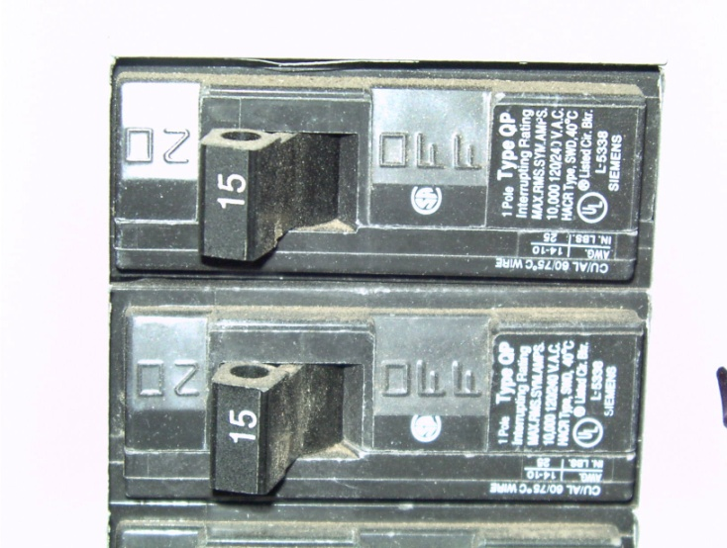
Circuit breaker.

Outlets

If an outlet is not working, check the breaker. If the breaker is on, but the outlet is still not working, contact an electrician.

Breaker Tripping

Breakers will often trip due to overloading the circuit by plugging too many appliances into it, a worn cord or defective item, or operating an appliance with too high of a power requirement. The starting of an electric motor can also trip a breaker.

If any circuit trips repeatedly, unplug all items connected to it and reset the breaker. If it trips when nothing is connected to it, you need an electrician and the problem should be reported via the warranty reporting process. If the circuit remains on, one of the items you unplugged is defective and requires repair or replacement.

GFCI (Ground Fault Circuit Interrupter)

GFCI breakers have a built-in element that senses fluctuations in power. Quite simply, the GFCI is an indoor circuit breaker. Installation of these receptacles is required by building codes in the bathroom, kitchen, and outside (areas where an individual can come into contact with water while holding as electric appliance or tool). Heavy appliances such as freezers or power tools will trip the GFCI breaker. Do not plug a refrigerator or food freezer into a GFCI controlled outlet; the likelihood of the contents being ruined is very high, and such damage is NOT covered by the limited warranty.

Each GFCI breaker has a test and reset button. Once each month the test button should be pressed. This will trip the circuit. To return service, press the reset button. If a GFCI breaker trips during normal use it may be an indication of a faulty appliance and some investigation is in order. An important point to remember is that one GFCI breaker can control up to three or four outlets.

Tamper-resistant Outlets

All outlets in your home are tamper-resistant, which means both prongs of a plug have to be inserted into the outlet at the same time. This is a safety feature that prevents foreign devices (knives, screwdrivers, etc) being inserted into one side and potentially causing electrocution. It is still advised that young children be supervised near open outlets.

Buzzing

Fluorescent fixtures use a transformer action to operate them. This action sometimes causes a buzzing sound and is a normal condition.

Exhaust Fans

The ceiling exhaust fan is used to remove unpleasant odors or moisture from a room. They are located in the bathrooms and are controlled by a wall switch. Newer fans are often barely audible so check closely before calling for service. Always use your exhaust fans when showering, and 15 minutes afterward, so that the moisture can be exhausted to the exterior of your house. If you do not use the fans, condensation can collect in the duct work and drip back down. This is not a roof leak.

Modifications

Do not tamper with or add to your electrical system. For any modification that is needed, contact a licensed electrician.

LIMITED WARRANTY

Any electrical wiring that fails to carry its designed load will be repaired to meet specifications. If electrical outlets, switches, or fixtures do not function as intended, Habitat will repair or replace them within the one-year warranty period. There is no warranty on fixtures supplied by the Homeowner.

Light fixtures are installed in the locations indicated on the house plans and will not be moved by Habitat. All fixtures are installed with appropriate wattage bulbs. The Homeowner is responsible for replacing any burned out bulbs other than those listed on the Walk through list. Be sure to replace the bulb with that of the same wattage, rated for the appropriate fixture. Using a bulb of higher wattage could be a fire hazard.

GFCI (Ground Fault Circuit Interrupter)

Habitat is not responsible for food spoilage that results from a Homeowner plugging a refrigerator or freezer into GFCI circuits.

Expansion and Contraction

Use and Care

All building materials are subject to expansion and contraction caused by changes in temperature and humidity. Dissimilar materials expand or contract at different rates. This results in separation between materials, particularly dissimilar ones. The effects can be seen in small cracks in drywall and in paint, especially where moldings meet drywall, at mitered corners, etc.

This can be alarming to an uniformed Homeowner but, in fact, it is normal. Shrinkage of the wood members of your home is inevitable. This will occur in your home. It will be most noticeable during the first year, but may continue beyond that time. In most cases, paint and caulking are all that is needed to conceal this minor evidence of a natural phenomenon. Properly installed caulking will shrink and must be maintained by the Homeowner.

Flooring: Carpet

Use and Care

Refer to manufacturer’s recommendations for additional information on the care of all floor-covering products.

Vacuuming high traffic areas daily will not only keep them clean but will help to maintain the upright position of the nap. Spills should be wiped up and stains spot cleaned immediately. Always dab at the stain, never rub it. Stain removers should be tested first on an out of the way area of the carpet, such as in a closet, to check for any undesirable effects. Professional or steam cleaning should be performed regularly, usually annually.

LIMITED WARRANTY

Carpet seams will be visible. No gap or fraying is acceptable, however. Edges of carpet along moldings and edges of stairs should be held firmly in place. In some areas, metal or other edging material may be used where carpet meets another floor covering.

Stains or spots noted at the end of construction will be corrected by cleaning, patching, or replacement. Habitat will not be responsible for dye lot variations if replacements are made. There is a one-year warranty for material defects from manufacturer and/or improper installation only.

Flooring: Vinyl and Laminate

Use and Care
To maintain your floors properly: 1. Wipe up spills immediately. 2. Remove dried spills with a cleaning solution intended for laminate or vinyl flooring 3 Do not use excessive water during regular cleaning. Damp microfiber mop pads are a good option. 5. Don’t use detergents, abrasive cleaners or "mop and shine" products - they may leave a dull film on your floor. 6. Don’t use paste wax or solvent-based polishes. 7. Don’t use a beater bar when vacuuming because it can visibly damage the floor surface. 8. Don’t use highly abrasive scrubbing tools.

Framing

LIMITED WARRANTY

Some floor squeaks are unavoidable. Although Habitat does not warranty against floor squeaks, a reasonable effort will be made to correct them one time only within the first year. Floors will deflect when walked on. This will be more noticeable next to hutches, bookcases, chairs, etc. This is not a structural deficiency and Habitat will take no action for this occurrence.

Level Floors

Floors will be level to within ½” over any 20’ distance on all new construction homes. Occasionally on rehabs, previous conditions will prevent this performance guideline from being met, but Habitat will bring floors as close to level as the existing structure of the home will safely allow. Walls that are out of plumb more than 1/4” over 8’ distance will be corrected by Habitat within the one-year warranty period.

Gas Shutoffs

Use and Care

There is a shutoff on the gas line at or near its connection to each item that operates on gas (dryer, furnace, hot water heater, range maybe). In addition, there is a main shutoff at the meter and just inside the house. These are pointed out during the Homeowner Walk through. If you suspect a gas leak, leave the home immediately and use a neighbors call the gas company or 911 for emergency service. Do not use your telephone, turn on/off any switches/appliances before leaving the home.

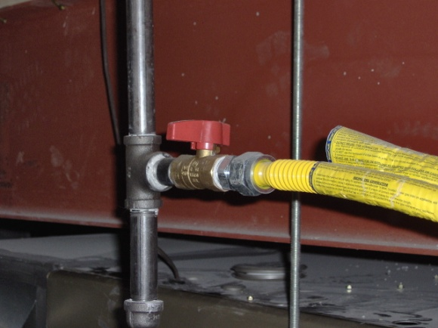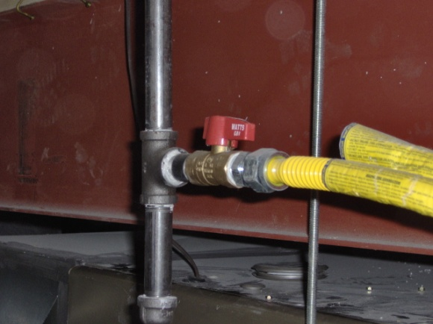

Gas in OFF position Gas in ON position

Grading and Drainage

Use and Care

The final soil level around your home has been inspected and approved for proper drainage of your lot. The local building authorities as well as our construction superintendent make inspections. Typically, the grade around your home should slope one inch in the first ten feet away from your home, and then continue to slope away from your property.

Positive Drainage

It is essential that you maintain the slopes around your home to permit the water to drain away from the home as rapidly as possible. Failure to do so can result in major structural damage and will void your warranty.

During construction, it is necessary to excavate an area larger than the foundation of your home. In addition, some trenching is necessary for installation of utility lines. Although the soil is replaced, it does not return to its original density. Some settling will occur, especially after prolonged heavy rainfall or melting of considerable amounts of snow. This can continue to occur for the first few years you are in your home, depending on the amount of precipitation that occurs and other factors.

Inspect the perimeter of your home regularly for signs of settling.

Roof runoff

Do not remove the splash blocks and/or downspout extensions from under the downspouts. Keep these in place at all times, sloped so the water drains away from your home quickly.

LIMITED WARRANTY

Back-filled or excavated areas around foundation and at utility trenches should not interfere with the drainage away from the house. If settling in occurs either in excess of 6 inches, or that prevents positive site drainage, Habitat will fill the settled areas one time during the first year.

The final grade is established to ensure adequate drainage away from the home. It is the Homeowner’s responsibility to maintain the drainage as established. If the drainage pattern is altered, either by action taken directly or instigated by the Homeowner or his agent, or as a result of neglect of maintenance, the warranty is void.

Swales (channels for water to drain)

In most cases, drainage swales do not follow property boundaries. Habitat will not alter drainage patterns to suit individual landscape plans. Typically a lot will receive water from and/or pass water on to other lots. For this reason, Homeowner changes in grade often affect lots that are nearby. Habitat advises Homeowner’s against making such changes.

Winter Grading

Due to weather conditions, especially during winter and early spring, it may happen that the final grade has not been established at the time of closing. When this is the case, Habitat staff will return in the spring to finish grading and landscaping.

Erosion

Habitat is not responsible for damage caused to non-landscaped yards by weather after the final grade has been established or the closing date, whichever occurs last.

New sod or grass seed

New sod and grass seed installation and the extra watering that accompanies it can cause temporary drainage problems, as can unusually severe weather conditions.

Recommendations

Habitat will inspect problems during the one-year warranty period and determine whether or not they are covered under warranty. If they are not, Habitat will advise the Homeowner as to corrective actions which he/she might take.

Gutters and Downspouts

Use and Care

Gutters must be checked every spring and fall and cleared of leaves or other debris. Materials that accumulate in gutters can slow the process of draining water from the roof, cause overflows, or clog the downspouts and lead to problems such as a leaking roof. Excess snow should be cleaned away from downspouts as soon as possible to allow the gutter to drain and prevent damage.

Ladders

Use caution when leaning ladders against gutters and siding as this may cause dents.

Leaks

If a joint between sections of gutter drips, caulk the inside joint using a gutter caulking compound available at hardware stores.

LIMITED WARRANTY

There is a one-year warranty for material defects from manufacturer and/or improper installation only. As part of normal maintenance, the Homeowner should keep gutters clear of debris that might clog them and cause the water to run over the downspouts. The Homeowner should check gutters every spring and fall to ensure proper functioning; excess snow should be brushed off downspouts with a broom as soon as possible. Severe ice or snow buildup can damage gutters.

Overflow

Gutters may overflow during periods of excessively heavy rain. It is expected that small amounts of water, but not exceeding ½” in depth, will stand for short periods of time in gutters immediately after rain. No correction is required for these conditions. Owner must keep the gutters from obstruction.
Downspouts

Downspouts are placed to carry water to the ground and in extensions, which then direct the flow away from the foundation of your home. These extensions are for the protection of the foundation; the Homeowner is responsible for maintaining them.

Hardware

LIMITED WARRANTY

Doorknobs and locks should operate correctly. Some slight adjustments may be needed due to normal shrinkage of the framing. Habitat will perform these adjustments one time in the first year.

Dents, chips, scratches, etc., in door hardware, towel bars, shower doors, etc., which are noted on the Walk through list will be repaired.

Heating System

Use and Care

The heating system installed in your home will provide you with many years of comfort if given proper care and maintenance.

Thermostat

A programmable thermostat was chosen for your home to help maintain a comfortable temperature and reduce heating bills. It can be set to automatically adjust to your specific heating requirements. The thermostat contains back-up batteries, which will keep your settings in case of an electrical power failure. These should be replaced each year in the fall. Operation instructions are on the back of the thermostat cover and in the manufacturer’s manual. Please read and follow the instructions to ensure the lowest heating costs.

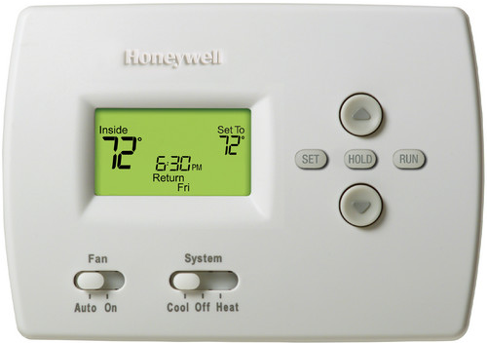
Thermostat.

Condensate Pump

A pump is used to remove water that is produced by the furnace and is plugged into outlet an located next to the furnace. Check monthly to be sure its internal circuit breaker hasn’t tripped. If the pump fails to come on, the furnace will not operate. Usually if the pump fails, you will see water on the floor under your furnace. Check the breaker if the furnace isn’t working.

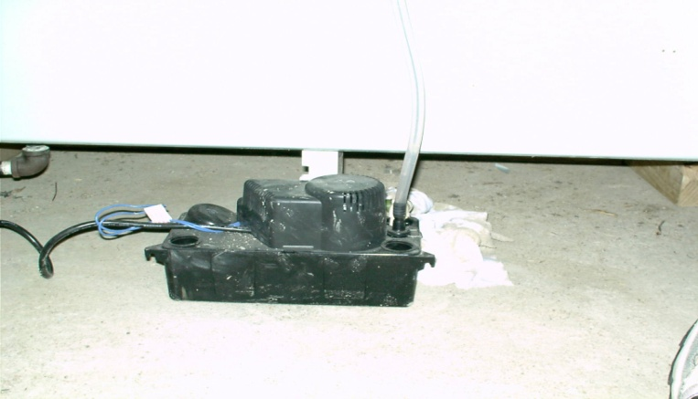
This is the condensate pump located near the furnace.

Annual Maintenance

Your heating installer recommends that you have your furnace cleaned and serviced once per year by a licensed heating company. Good maintenance of the furnace can save energy dollars as well as prolong the life of the furnace itself. Carefully read and follow the manufacturer’s literature on use and care. The guidelines here include only general information.

Troubleshooting

If your furnace is not working, there are a few things you can check. First, the furnace has an on/off power switch. This switch looks like a regular light switch. It is located in a metal box outside the furnace. This switch simply overrides all furnace commands and manually shuts down the blower. You can use this switch as a reset to try and start the furnace if it is not working.
Next, check to make sure that the condensate pump is plugged in and working. Pour some water into the pump (where the small hose attaches) until the box is full. The pump should turn on once it is filled. If not, make sure it is plugged in and try resetting the breaker.

Then, make sure your thermostat is set to “heat” and set at a temperature higher than the current temperature of your house.

Check to make sure that your furnace filter has been changed.

Your furnace has an LED code system to troubleshoot why it is not working. Open/remove the door panel on the furnace and look for a red LED light. If the furnace is functioning properly, the light will be solid. When there is a problem, the light blinks a code which corresponds to what is wrong. The code list will either be on the back of the door, or in the booklet that came with the furnace.

If you can’t get your furnace to work after trying these things, call a heating contractor to inspect the equipment.

Filter

Remember to change the filter monthly during the heating season. The furnace filter removes dust and debris from the air coming from the home back through the furnace to be heated. A clogged filter can slow airflow and cause cold spots in your home. Although it takes less than one minute to change the filter, this is one of the most overlooked details of normal furnace care. Buy filters in large quantity for the sake of convenience. A dirty filter can increase heating costs by 5-25% and can result in hundreds of dollars of repair to your furnace. The filter is located in a slot in the ductwork right next to your furnace. Identify the dimensions labeled on the side of the filter to ensure you’re replacing with the proper size.

Adjust Heat Vents

Experiment with the adjustable registers in your home to establish the best heat flow for your lifestyle. Generally, heat can be decreased in seldom used or interior rooms. This is a very individual matter and you will need to balance the system for your family.

If you don’t feel warm air coming through a vent, it is likely a cold air return, where air goes from the house back to the filter. Keep this vent open and clear.

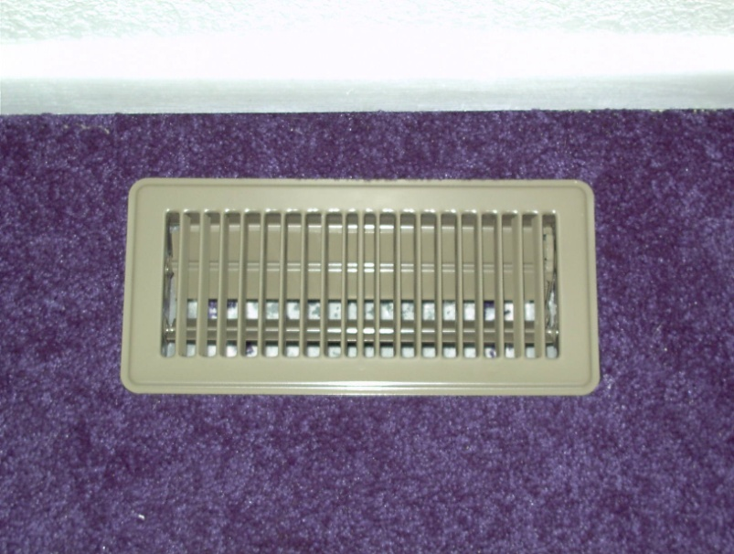
Adjustable heat vent.

Return Air Vents

For maximum comfort and efficient energy use, place furniture and draperies to allow unobstructed airflow from registers and cold air returns.

Temperature

Normal temperature variations from floor to floor (depending on the style of home) can be as much as 10 degrees or more on extremely cold days. The furnace blower will typically cycle on and off more frequently and for shorter periods of time during severe cold spells.

Overheating

Your new home should not be overheated. Overheating can cause excessive shrinkage in framing lumber and may materially damage the home. In the beginning, use as little heat as possible and increase it gradually.

Odor

It is normal for the heating system to emit odors for a few minutes when it is first turned on after an extended period of not being used. This is caused by dust that has settled in the ducts and should pass very quickly.

Gas

If you smell gas in the house, have everyone leave immediately and meet at a pre-determined place outside the home. Do not use matches or any type of open flame in an attempt to re-light any appliance as it may cause an explosion. Call the gas company or 911.

LIMITED WARRANTY

There is a one-year warranty for material defects from manufacturer and/or improper installation only. Heating systems will be installed in accordance with local building codes, as well as engineering designs of the particular model home. Adequacy of the system is determined by its ability to establish a temperature of 70 degrees, as measured in the center of the room. In extremely cold temperatures (10 degrees below or colder), the system should be able to maintain a temperature differential of 80 degrees. Thermostats are calibrated to plus or minus 5 degrees.

There is also a manufacturer’s warranty for the furnace itself. You also must register your furnace within 90 days of purchase.

Furnace Sounds

Expansion or contraction of metal ductwork will typically result in some ticking or popping sounds. This is a normal condition and it is not possible to eliminate these sounds.

Ductwork

The heat system is a sealed system and the ductwork should remain attached and securely fastened. If it becomes unattached, contact a licensed heating contractor to perform repairs.

Landscaping

Use and Care

Grass

When grass is installed, it needs a lot of water every day until the grass roots get established (about 4-6 weeks). Habitat staff or volunteers will help educate you as to how much and how often to water. Stay off the lawn as much as possible during this time. After the grass starts to grow, begin a regular schedule of cutting and fertilizing. Carefully follow manufacturer’s directions for fertilizing and spraying. Do not remove more than 1/3 of the grass height with each mowing. Cutting more than this may harm your lawn.

Drainage

The necessary grades have been established by Habitat to ensure proper drainage away from the house. Standing water shall not remain for extended periods of time in the immediate area of the house after a rain shower (generally, no more than 24 hours) except in swales that drain other areas. In these areas, a longer period can be anticipated (generally, no more than 48 hours). The homeowner should anticipate the possibility of standing water after an unusually heavy rainfall.

LIMITED WARRANTY

Habitat will not be responsible for replacing grass that dies or doesn’t grow due to improper watering.

Mirrors

Use and Care

To clean your mirrors use any reliable liquid glass cleaner or polisher available at most hardware or grocery stores. Avoid splashing water under the mirror. The moisture will cause the silvering to deteriorate.

LIMITED WARRANTY

Scratches, chips, or other damage to mirrors noted at the end of construction will be corrected by Habitat.

Paint and Stain

Use and Care

The interior woodwork, as well as the bathrooms and kitchen walls have been painted with latex paint. These areas may be wiped down with a soft sponge and soapy water. Spackle may be used to cover any small defects prior to paint touch-up.

Touch-ups

Homeowners will receive a sample of interior and exterior paint used on their homes. This paint should be stored so as not to be affected by freezing temperatures. When doing touch-up painting, use a small brush, applying paint only to the damaged spot. The paint may not match the surrounding area exactly, even if the same paint mix is used. When it is time to repaint a room, prepare the wall surfaces first by cleaning with a mild soap and water mixture or a cleaning product that is recommended by the manufacturer.

Wall Cracks

Do not attempt to fix drywall cracks or other separations due to shrinkage until after the first heating season. See “Drywall” for additional information concerning repairs.

Exterior

Regular painting and repair will preserve the beauty of and add value to your home. Check the painted/stained surfaces of your home’s exterior annually. If you repaint before there is much chipping or wearing away of the original finish, you will save the cost of extensive surface preparation. It is a wise maintenance policy to plan on refinishing the exterior surface of your home approximately every three years. The aging of the exterior is governed by the climatic conditions. Over a period of time, this finish will fade and dull a bit.

Maintenance

When you wish to repaint and/or stain the exterior on your home, popped nails should be reset; the blistered or peeling portions should be wire-brushed or scraped with a putty knife, sanded, and spotted with primer. Then the entire area can be painted and/or stained. Be certain to apply a top quality exterior paint that has been formulated for local climate conditions. Do not allow water to spray on the exterior walls of your home. This will cause blistering, peeling, splintering, and other damage to the home. Trim painted white or light colors will more readily show grain and cracks and therefore requires additional maintenance.

Severe Weather

Hail and wind can cause a great deal of damage in a severe storm and the house should be inspected after such weather. Damage caused by severe weather should be reported to your insurance company promptly.

LIMITED WARRANTY

The construction supervisor and the Homeowner will be responsible for signing off on the paint job at the punch-list walkthrough. The Homeowner is responsible for all subsequent touch-ups.

Wood Grain

Due to wood characteristics, color variation will result when stain is applied. There will be no repair or replacements on such variations.

Fading

Fading of exterior paint or stain can be expected due to the effects of sun and weather. No warranty repair is provided for this occurrence.

Phone Jacks

Use and Care

Each home is equipped with one telephone jack. Initiating phone service is the Homeowner’s responsibility. Moving outlets for decorating purposes or convenience is an owner expense.

Limited Warranty

Wiring that does not perform as intended from the phone service box into the home will be repaired by Habitat within the one year warranty period. From the service box outward, care of the wiring is the responsibility of the local telephone service company.

Plumbing

Use and Care

Your main water shutoff is located in your basement near the street. It is important to know and remember the location of the shutoff for emergencies such as a water line freeze or break.

Freezing Pipes

Provided the home is heated at a normal level, pipes should not freeze at temperatures above 0 degrees Fahrenheit. Heat should be set at 55 degrees if you will be away for an extended period of time; and it is best to drain your water supply lines. This is done by shutting off the main supply line and opening the faucets to relieve the pressure in the lines

Debris in Pipes

Even though your plumbing lines have been flushed out to remove dirt and foreign matter, there are usually small amounts of minerals that enter the line. Aerators on the faucets strain much of this from your water. However, debris caught in these aerators may cause the faucets to drip because washers wear more rapidly when they come in contact with foreign matter.

Care and Cleaning

Follow manufacturer’s directions for cleaning fixtures. Abrasive cleansers will remove the smooth finish leaving behind a porous surface that is difficult to maintain. A non-abrasive cleaner or liquid detergent is usually recommended.

Stainless Steel

Stainless steel sinks should be cleaned with soap and water to preserve their luster. Do not use abrasive cleaners; they will damage the finish. An occasional cleaning with a good stainless steel cleaner will enhance the finish. Care should be taken to avoid leaving produce on a stainless steel surface since prolonged contact with produce can stain the finish.

Synthetic Countertops

You should not use abrasive cleanser or razor blades on countertops since both will cause certain damage to the surface.

Fixtures

Clean plumbing fixtures with a soft sponge and soapy water, then polish with a dry cloth. Drying with a soft cloth or towel will prevent water spots.

Toilet Tank Care

Avoid exposing the toilet to blows from sharp or heavy objects; this can cause chipping or cracking. Avoid abnormal pressures against the sides of the tank. It is possible to crack the tank at the points where it is attached to the bowl.
Condensation on the tank of the toilet is common, and is a result of the cold water inside the tank meeting warm air outside the tank. Occasionally, if the house is warm or humid enough, this can result in dripping. This is not a warranty issue, and it is advised to keep the floor free from standing water if this occurs.

Low Pressure

It will occasionally be necessary to remove and clean the aerators on faucets to allow proper flow of water, normally every three to four months is sufficient. You can do it more often if you notice a pressure reduction.

Leaks

If a major plumbing leak occurs the first step is to turn off the supply of water to the area involved. This may mean shutting off the water to the entire house. Then contact Habitat.

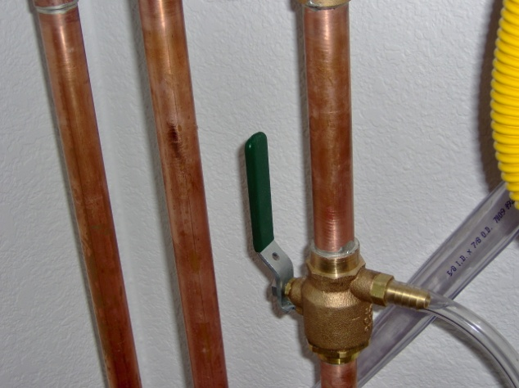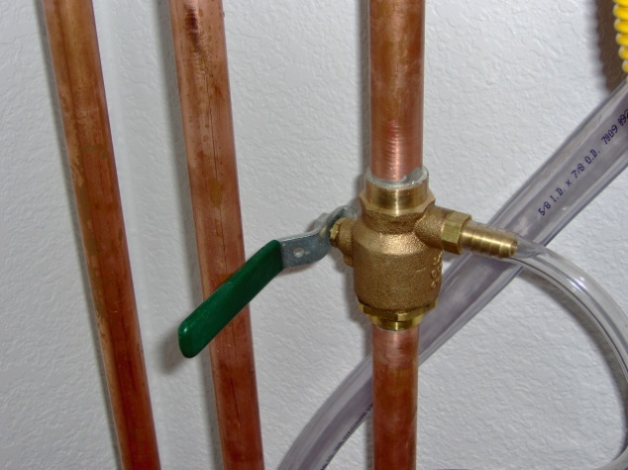
Water valve in “on” position Water valve in “off” position

Running Toilet

To stop running water, check the shutoff float in the tank. You will most likely find it has lifted too high in the tank, preventing the valve from shutting off completely. In this case, there is usually a screw that you can turn to adjust the float. Turn the screw a little bit and flush the toilet to see it it has improved. Use trial and error to figure out how to get the screw adjusted properly.

Clogs

Clogged toilets can usually be cleared with a plunger. If you use chemical agents, follow directions carefully to avoid injury or damage to you or the fixtures.

Outside Faucets

Turn the faucet off until water drains out the back of the spigot. This feature keeps this faucet from freezing. Remove any hoses as soon as the outside temperature falls below 35 degrees. The water left in a hose can freeze; expand back into the pipe, causing a break in the line. Repair of a broken line to an exterior faucet is not covered by warranty.

LIMITED WARRANTY

All drains and sewer lines should operate freely. Habitat will correct clogged drains resulting from construction debris that occur during the first 30 days after closing. Obstructions removed during this time period, which are shown to be the result of Homeowner’s action, will be corrected at the Homeowner’s expense.

Leaks

If a plumbing leak caused by Habitat’s or a subcontractor’s work occurs within the two-year warranty period, Habitat will fix it. Leaks that are caused by negligence such as not unhooking a hose will not be repaired by Habitat.

Freezing Pipes

Provided the home is heated at a normal level, pipes should not freeze. Heat should be set at 55 degrees if you are away during winter months.

Cosmetic Damage

Any fixture damage noted on the Walk through list will be repaired. Chips, scratches, etc., reported subsequent to the Walk through list will not be repaired. The Homeowner is responsible for following manufacturer’s directions for caring for fiberglass products.

Exterior Faucets

Habitat will repair any problems with these faucets noted on the Walk through list. Afterward, repairs of broken lines to exterior faucets will be the Homeowner’s responsibility.

Roof

Use and Care

The shingles on your roof do not require any treatment or sealer. Never attempt to walk on the roof of your home as you can easily damage the shingles. If, for any reason, you need to walk on the roof, take great care to avoid falls, coming in contact with overhead power lines, or damaging the flashing and vent stacks.

Severe Weather

After severe storms, a visual inspection of the roof for damages is called for. Notify your homeowner insurance company if damage is noted.

Leaks

When a leak is noticed try to detect the exact location; this will greatly simplify locating the area that requires repair when the roof is dry.

LIMITED WARRANTY

Roof and flashing should not leak. Habitat will repair roof leaks other than those caused by severe weather, such as hail damage, or some action by the Homeowner within the one-year warranty period. Roof repairs are only made when the roof is dry.

Ice Buildup

Ice buildup may develop in the eaves during extended periods of cold and snow. Damage that results from this is normally covered by the Homeowner insurance and is not a warranty item.

Siding

Use and Care

The vinyl siding on your home is very low-maintenance but should be hosed off or pressure-washed with a low angle nozzle annually to avoid buildup of mold, moss or other surface debris that can reduce the lifetime of the product
Note that vinyl siding will fade over time due to exposure to the sun. Repairs and replacements likely will not match perfectly.

LIMITED WARRANTY

Defects in the siding of the home should be noted during the punch-list walkthrough. Habitat will repair any defects noted at the end of construction. Siding should not come loose or detach from the home, and any such issues will be repaired by Habitat Buffalo during the first year.

Smoke Detectors

Use and Care

Each smoke detector is permanently wired to the house electrical system and has back up batteries to operate the unit in case of electrical power failure. Read the manual from the manufacturer for information on the care of smoke detectors.

Cleaning and Batteries

Once every 6 months smoke alarms should be cleaned (vacuumed) to prevent a false alarm or lack of response in a fire. After cleaning, push the button to test; the alarm should sound. For your safety, it is important that these devices be kept clean and in good operating condition.

Batteries should be changed every 6 months. Be sure to use only new, unused batteries of the same type as originally installed. After installing the new battery, push the button to test; alarm should sound.

LIMITED WARRANTY

Habitat does not represent that the smoke detection device will provide the protection for which it is installed or intended. Insurance, if any, must be obtained by the Homeowner.

Stairs

Use and Care

There is no known method of installation that will prevent vibration in a staircase when used by adults. Often there will be a slight shrinkage where the stairs meet the wall. When this occurs, a thin bead of latex caulk can be applied and when dry, painted to match the wall

See also: Caulking, Framing

Sump Crock and Pump

Use and Care

The sump crock and pump is in the basement and is connected to the underground foundation drains. If there is too much groundwater (from rain, for example) for the ground to absorb, it will travel down to the drain and into the sump crock. Once the water level reaches a certain height in the crock, the pump turns on to drain the excess water to the exterior or the municipality’s storm water system.

There is a cover on top of the crock. The crock is potentially dangerous to children who may wander into the crawl space. Please keep it covered and consider taping it shut or blocking it off.

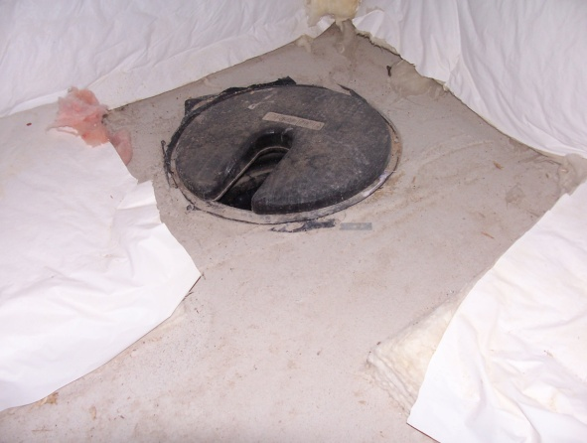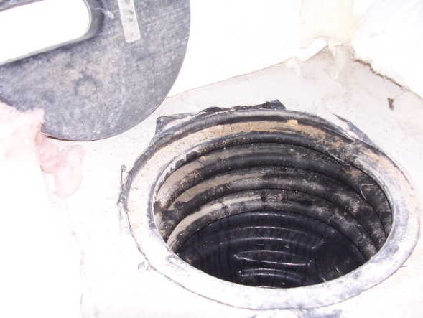
Sump pit covered Sump pit uncovered

Vents

Use and Care

Attic ventilation through the roof or siding is required by building codes and therefore cannot be obstructed.

Limited Warranty

Attic ventilation is required by the building codes and therefore cannot be omitted. Occasionally, depending on the force and direction of the wind, rain or snow will infiltrate through these vents causing spotting on the ceiling. Habitat is not responsible for such weather damage and will not make repairs in these instances.

Waterproofing

Use and Care

Your exterior crawl space foundation walls have been covered with a damp-proof membrane. A French drain has been installed below the footer. There is a sump crock and pump, or a floor drain in the basement. While every effort has been made to eliminate any seepage, during times of excessive moisture some dampness may be noticed. maintenance of positive drainage will also protect your crawl space from this condition.

LIMITED WARRANTY

Actual flowing water entering the basement should be reported to Habitat. Unless flowing water is caused by the Homeowner changing the positive drainage to the exterior, or the municipality’s storm water drainage system has backed up, Habitat will perform repairs to provide adequate waterproofing of the basement.

Windows, Screens, and Patio Doors

Use and Care

In heavy rains water may collect in the bottom channel of window frames. Weep holes are provided to allow excess water to escape to the outside. Keep the bottom window channels and weep holes free of dirt and debris for proper operation.

Cleaning

Once a month, clean aluminum and vinyl surfaces with warm, clear water. Do not use any powdered cleaner. After each cleaning, apply a silicone lubricant.

Ventilation

Proper ventilation will prevent excessive moisture from forming on the inside of the windows. This helps reduce cleaning chores considerably.

Condensation

Condensation on interior surfaces of the window and frame is the result of high humidity within the home and low outside temperatures. The humidity level within the home is largely influenced and controlled by your family’s lifestyle.

Sticking Windows

If sticking occurs or excessive pressure is required to open or close, a silicone lubricant should be applied. This is available at hardware stores. Do not use a petroleum-based material.

Window Locks

Acquaint yourself with the operation of the window hardware for maximum security.

Broken Glass

If any panes of glass become broken you should contact a glass company for reglazing. Glass is very difficult to install without special tools. Habitat is not responsible for broken windows after occupancy unless they were noted on the Walk through list.

LIMITED WARRANTY

There is a one-year warranty for material defects from manufacturer and/or improper installation only.

Operation

Windows should operate with reasonable ease and locks should perform as designed.

Condensation

Condensation on interior surfaces of the window and frame is the result of high humidity within the home and low outside temperatures. The humidity level within the home is controlled by the Homeowner and requires no corrective action by Habitat.

Appliance Serial Numbers

Appliances come with instruction manuals and warranty cards. Register your warranties with their manufacturers by completing and mailing the warranty cards immediately. Read the manuals and keep them available for reference. For warranty service, contact the appropriate manufacturer directly at the service number provided in the appliance literature. You will need to supply the model and serial number, and the date of purchase (the closing date). Use this form to record this important information.

Appliance Manufacturer Model # Serial # Customer Service #

